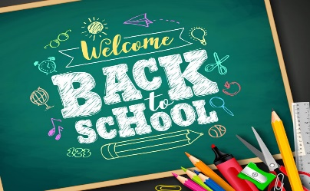
SPEMA 2022-2023
School Supply List
(Additional Fees)
- Registration (All Students)
- Dance
- Robotics/Engineering
- Business
- 8th Grade Activities
- Music
- Sports
- Clubs
- School Events

*Additional fees may be incurred pending student’s course schedule, grade level, and/or interests. More information will be provided.
(All Grades 6-8)
- 1- 3” Binder
- One 8-Pack Dividers
- 3-Pk Loose Leaf Paper
- 24-Pk Pens (blue, black, and red ONLY)
- 24-Pk Pencils & Hand-held Pencil Sharpener
- 2 Composition Books
- 4 Pocket Folders (with brads/fasteners)
- 1 Pencil Holder (bags ONLY)
- 1-Pk Highlighters
- 2-Pks Index Cards (lined)
- Ruler
- One set of earphones/buds

***You can visit http://www.ebrschools.org/quick-links/ to submit fee payments***

